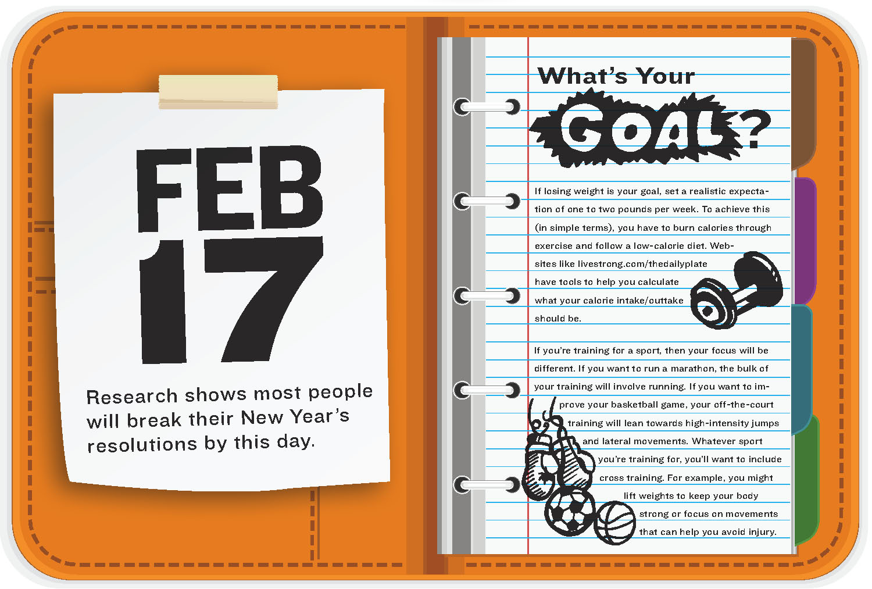

**[Your Name]**

[Height & weight]

[Pre-Fitness Score Push Up]

[Pre-Fitness Score Curl Up]

[Pre-Fitness Score Flexibility]

[Pre-Fitness Score Aerobic Capacity]

Review your baseline fitness scores and describe the activities you like to do and the goals you have set.

SMART FITNESS GOALS

* [Describe a short term nutrition goal here]
* [Describe a short term muscular strength goal here]
* [Describe a short term muscular endurance goal here]
* [Describe a short term cardiovascular goal here]
* [Describe a short term flexibility goal here]
* [Select the fitness goal that is most important to your client. Describe a long term goal here.]

Write a positive statement here! Explain what you love to do for fun to get some exercise!

Insert your favorite Cardiovascular Endurance exercise here. Pick an activity you enjoy doing. You can use google images, draw, or take your own photo.

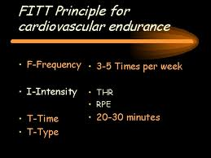

Insert your photo here!

“INSERT A FITNESS QUOTE” HERE.”

Insert photo of Muscular Strength here. Pick an activity you enjoy doing. You can use google images, draw, or take your own photo.

Nutrition Plan

Nutrition is important for all around fitness. The foods and drinks we consume play a major part in our overall wellness. If we eat more calories than we burn, then weight gain will happen. But did you know the *types* of food we eat effect how we feel? This means that some foods increase chances of weight gain, but also make us feel like not moving. It is important to eat a high quality diet to help us manage calorie balance **and** make us feel like we want to get up and move, dance, play sports, etc..

Your fitness team has worked together to create a total fitness plan for you. The nutrition trainer has created a sample day for you:

**Breakfast –** [list all the foods the client should eat for this meal. ]

**Snack –** [list all the foods the client should eat for this meal]

**Lunch –** [list all the foods the client should eat for this meal]

**Snack -** [list all the foods the client should eat for this meal]

**Dinner -** [list all the foods the client should eat for this meal]

**Recommended Recipe –** [select a recipe from [MyPlate sample recipes](http://www.choosemyplate.gov/healthy-eating-tips/sample-menus-recipes.html) Describe the recipe, include the web page link and picture.]

1. **Muscular Strength/Endurance Overload:** To help you improve [client’s muscular strength or endurance goal] you will need to increase [describe activity here].
2. **Cardiovascular Fitness Overload:** To help you improve [client’s cardiovascular fitness goal] you will need to increase [describe activity here].

**OVERLOAD**

Insert photo of one of the recipes described above.

Insert photo of Flexibility here. Pick an activity you enjoy doing. You can use google images, draw, or take your own photo.

Insert photo of Muscular Endurance here. Pick an activity you enjoy doing. You can use google images, draw, or take your own photo.

**[Choose (1) goal for your client to create a progression):** The best way to help you [describe client’s goal] we will need to increase the amount of [describe specific exercises prescribed for your client aligned with goals] by gradually increasing the number of sets and reps for muscular strength and endurance, or by increasing the time exercising for cardiovascular fitness. The progression plan will be:

* 1. **Week 1 [describe frequency, intensity level, type, and time, of the exercise you are prescribing for your client]**
  2. **Week 2 [same as above but increase the load no more than 10% increase from previous week]**
  3. **Week 3 [same as above but increase the load no more than 10% increase from previous week]**
  4. **Week 4 [same as above but increase the load no more than 10% increase from previous week]**

**PROGRESSION**